标题：Intel 10th Gen Comet Lake U series CPU I3 I5 I7 NUC PC

关键词：NUC,NUC PC,Intel NUC Mini PC

ZC-NUC10 NUC PC Onboard Intel 10th Gen Comet Lake U series CPU I3 I5 I7 with 3*USB 3.1+1*USB Type C,HDMI Display

Thunderbolt3 Port

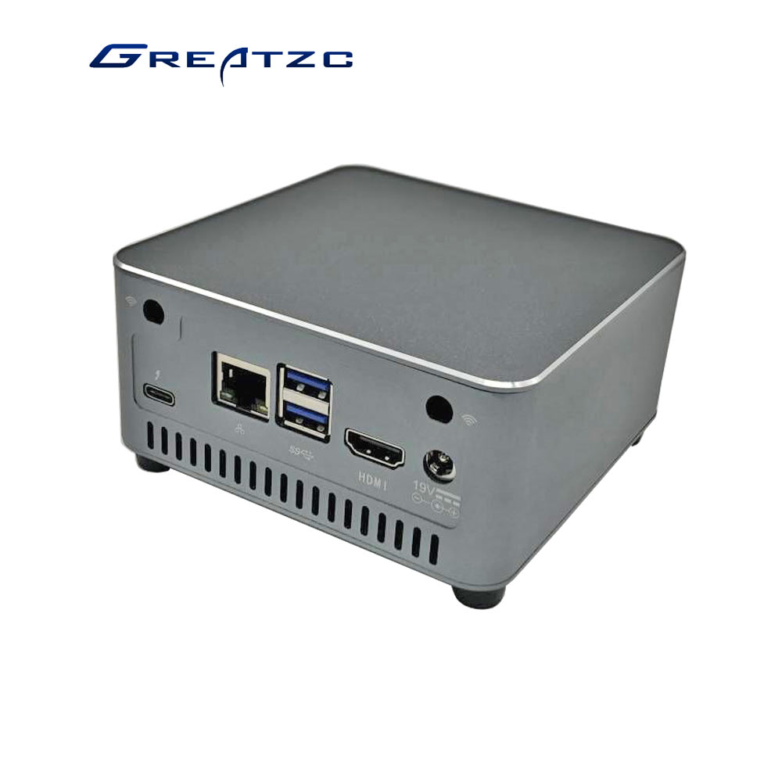

**Features:**

1. Supports 10th Gen Comet Lake U series CPU I3 I5 I7

2. Intel i225V 2.5G wired network card

2. Dual-channel DDR4/SO-DIMM supports up to 64GB

4. Storage 1*2.5’’ Slot+1*M.2-M(SATA/NVME)

5. HDMI 2.0, Thunderbolt3 (VGA/HDMI/DP)

6. With 1*M.2-E(PCIEI)WIFI Slot

7. 12V~19V wide voltage power supply

**ZC-NUC10 NUC PC Onboard Intel 10th Gen Comet Lake U series CPU I3 I5 I7**

|  |  |  |
| --- | --- | --- |
| Chassis | Material | Aluminum alloy |
| Color | Silver/black |
| Size | 112*112*55mm |
| Weight | 0.6 Kg |
| Motherboard | CPU | 10th Generation Intel Comet Lake U Serial CPU  I3-10110u: 2.10 GHz~4.10 GHz  I5-10210u: 1.60 GHz~4.20 GHz  i7-10510u: 1.80 GHz~4.90 GHz |
| Chipset | Soc |
| Display | Intel UHD Graphics |
| Network Card | Intel i225V 2.5G |
| Memory | 2*DDR4 SO-DIMM,Up to 64GB |
| Storage | 1*2.5’’ Slot,1*M.2 M Key (SATA/NVME) |
| Extend | 1*M.2-E Key(PCIEI)WIFI Slot |
| I/O Ports | Front | 1*Power Button |
| 1*IR |
| 1*Earphone(MIC+LINE-OUT) |
| 1*USB3.1 |
| 1*Type-C |
| Rear | 1*Thunderbolt3 |
| 1*LAN |
| 2*USB3.1 |
| 1*HDMI |
| 1*DC_IN |
| Software Support | System | Supports windows 7/windows 10,Linux ubantu 16.04,CentOS 7.0 |
| BIOS | AMI 128M BIOS |
| Cooling | Cooling | Active cooling with FAN |
| Power | Input | 12V~19V |
| Environment | Working Temp | -10~60℃ |
| Storage Temp | -20~70℃ |
| Working Humidity | 0% ~ 95% Relative humidity, non-condensing |

